BUILDING FIRST JOB IN JENKINS

1. Install git on the Linux terminal and clone the repository URL. Choose Git under Source Code Management and update GitHub Repository name and branch details as shown in the below screenshot.

**yum install git**

**git clone https://github.com/chaitanyagaajula/repo290720.git**

2. Create a job named as job1 and choose type as Freestyle Project in Jenkins Console

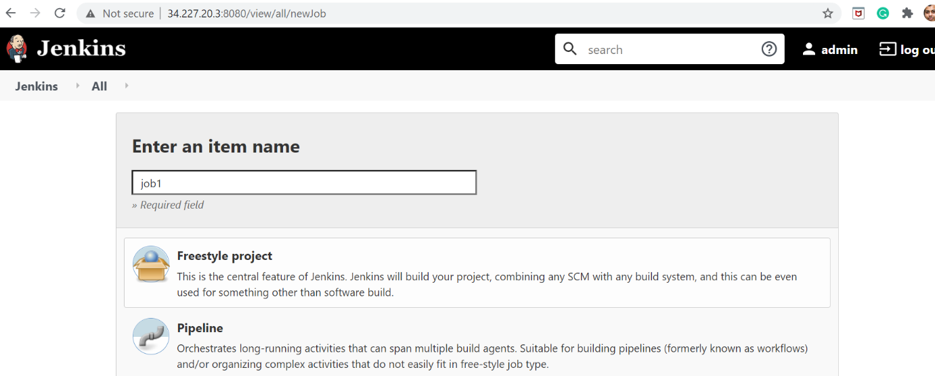

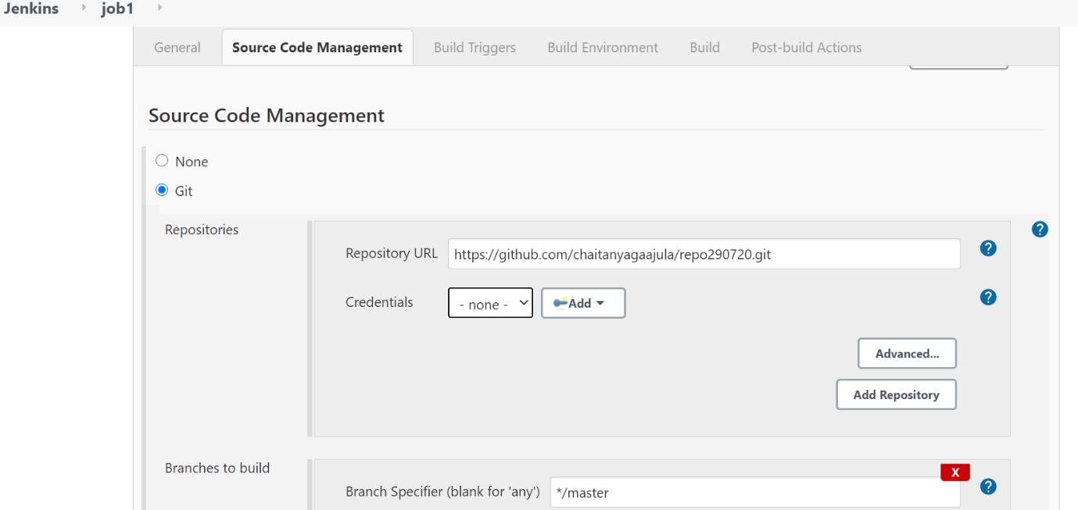

3. Choose the option “GitHub trigger” under Build Triggers section. Click on Apply and Save button.

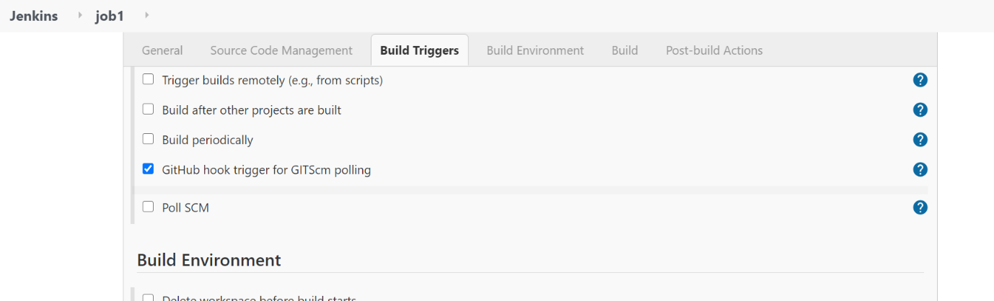

4. Access repository in GitHub and update the Webhook details as given below and Click on Add Webhook button

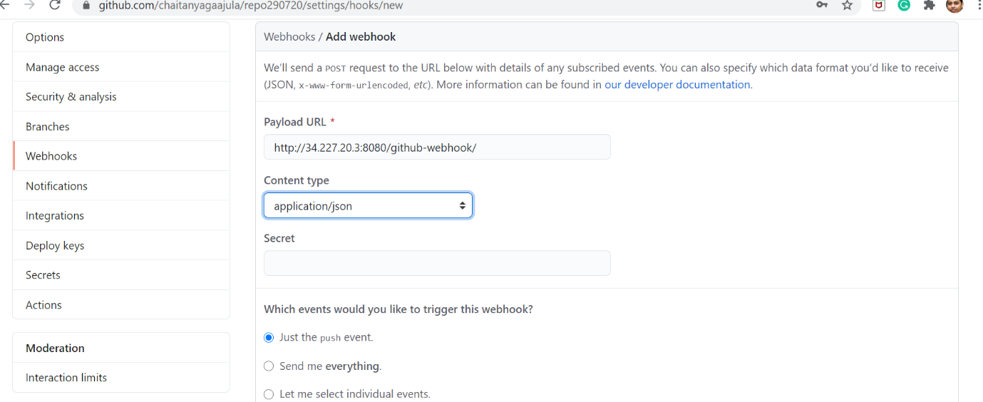

5. Commit a new file in the repository.

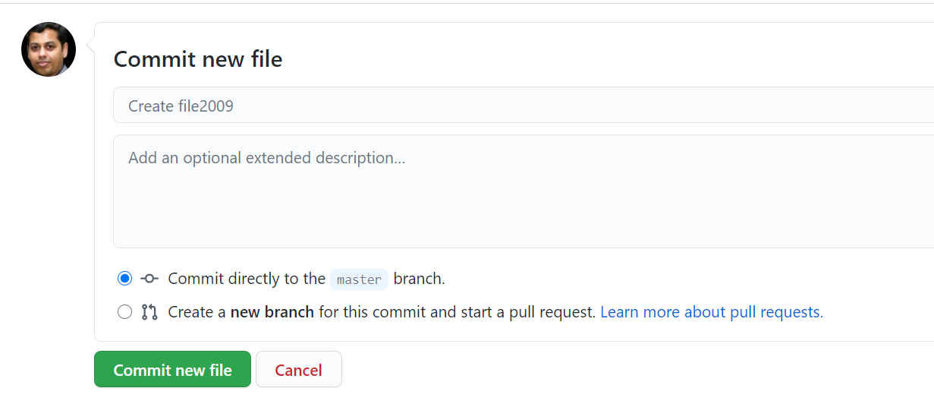

6. Under Jenkins Dashboard, it will start building the file which was committed recently.

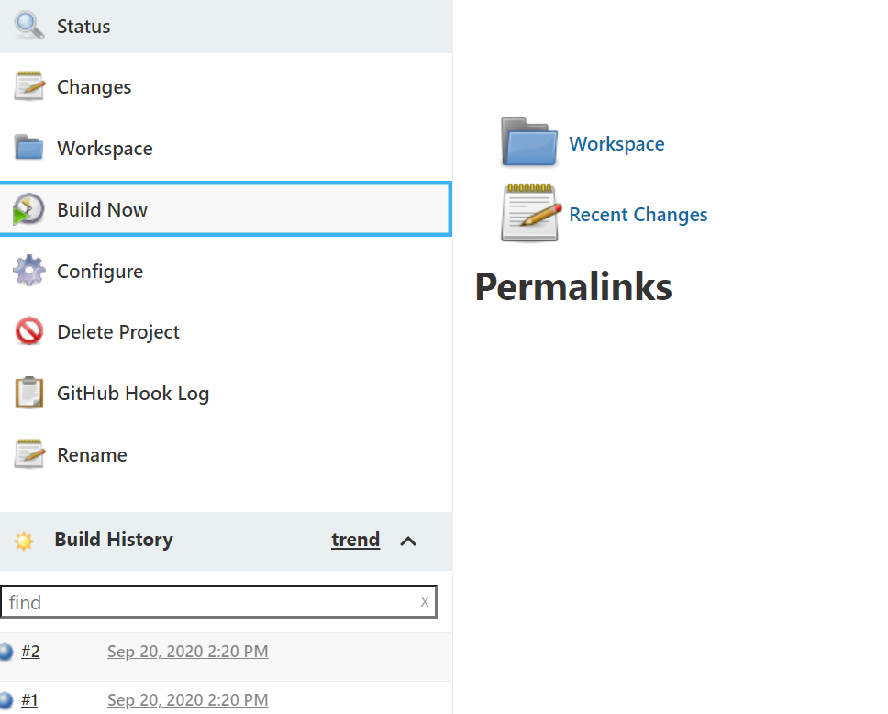

7. Observe the build details under Console Outputs and Workspace folder.

